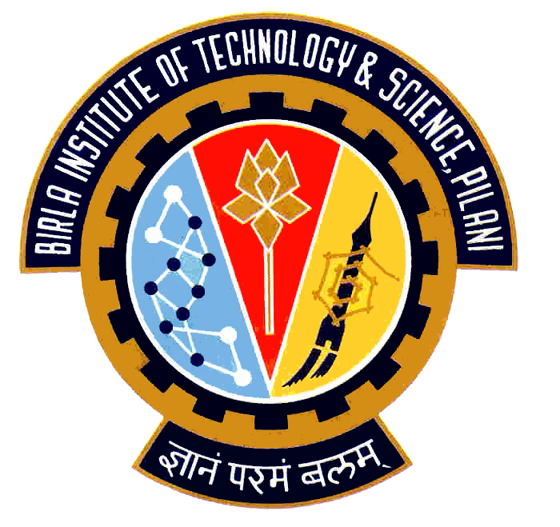

Election Commission

Birla Institute of Technology & Science – Pilani, Goa Campus, Zuarinagar, Goa-403726, INDIA
Tel: (0)98233 6368 Fax:0832-2557033

Final List of Candidates for the Executive Committee
PRESIDENT
SOURABH AGRAWAL | 2006P8PS441
ABHAY EGOOR | 2006P3PS083
VICE PRESIDENT
ABHINEET PRASAD | 2006P8PS147
BUDDHARAJU VINAY VARMA | 2006S1P4561
SHOUNAK SEN SHARMA | 2006P1PS463
ABHIMANYU VATSYA | 2006P8PS028
ANGAD PAL SINGH TIWANA | 2006P8PS190
DIVESH KUMAR | 2006P3PS173
TREASURER
RANJITH REDDY VEMULA | 2006P4PS098
C VARUN VENKATESH | 2006P1PS239
GENERAL SECRETARY
K GAGAN KUMAR | 2007P8PS283
SIDDHARTH PATWARI | 2007P8PS297
K PRITHVI | 2007P8PS243

Chief Warden CEC

In case of any discrepancy, contact Sanchit Kakkar, Chief Election Commissioner (9823306368)

